# QUESTION/ANSWERS

1. Break : it is use to terminate the loop.

Continue : it is used to go to next iteration of that loop.

1. If a variable is declared in the for-loop control, can it be used after the loop exits?

No it cannot exist outside the loop.

1. Can you convert a for loop to a while loop? List the advantages of using for loops.

* Yes, we can, we just have to restructure the position of expression.
* In “for” loop we can predict the memory usage, unlike “while” loop in which memory cannot be fixed

1. Do the following two loops result in the same value in sum? Yes they give the same result.
2. What does the following statement do?

for ( ; ; ) {

do something;

}

It will do something continuously with no limit.

6. Use a switch statement to rewrite the following if statement and draw the flow chart for the switch statement:

switch (a) {

case 1:

x += 5;

break;

case 2:

x += 10;

break;

case 3:

x += 16;

break;

case 4:

x += 34;

break;

}

7. What data types are required for a switch variable? If the keyword break is not used after a case is processed, what is the next statement to be executed? Can you convert a switch statement to an equivalent if statement, or vice versa? What are the advantages of using a switch statement?

switch works with the byte, short, char, and int primitive data types.if we don’t use break then the case will move to the next case instead of breaking out that point on.

Yes they can be converted. An advantage of it is that definite values are being compared that is not too ambiguous to understand.

8. For each of the specified set of strings write a regular expression

i. 01*111

ii. 01+

iii. 0* | 0*10*

iv. (a-z,A-Z)*main(a-z,A-Z)*

v. (A-W,Y-Z,a-w,y-z)*x+xx

9. Which of the following is a possible output from invoking Math.random()? 323.4, 0.5, 34, 1.0, 0.0, 0.234

It is random, no definite answer can be given.

Programming Exercise

1. If today is Saturday, it will be Saturday again in 7 days. Suppose you and your friends are going to meet in 10 days. What day is in 10 days? Write a program to compute the day.

import java.util.Scanner;

public class Main

{

public static void main(String[] args)

{

System.out.println("Today is Sunday. Enter number to find the day ");

Scanner sc = new Scanner(System.in);

int k = sc.nextInt();

int num = k%7;

if(num==0)

{ System.out.println("Today is Sunday");

}

else if(num==1)

{ System.out.println("Today is Monday");

}

else if(num==2)

{ System.out.println("Today is Tuesday");

}

else if(num==3)

{ System.out.println("Today is Wednesday");

}

else if(num==4)

{ System.out.println("Today is Thursday");

}

else if(num==5)

{ System.out.println("Today is Friday");}

else if(num==6)

{ System.out.println("Today is Satuday"); }}}

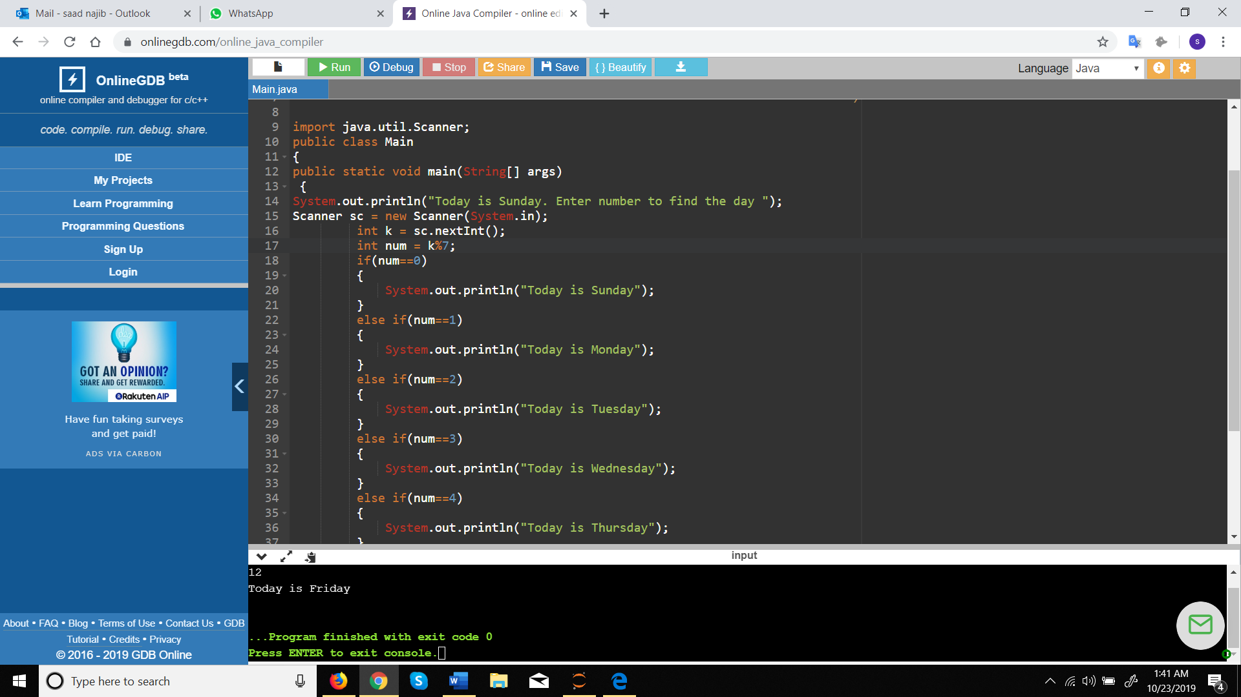

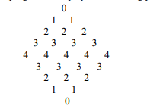 2. Write a program to display the following pattern by using loop:

public class Main

{

public static void main(String[] args) {

int num=5;

int num1=5;

int num5=3;

int num3=1;

System.out.println();

for(int i =0;i<10;i++)

{if(i<5)

{for(int j=1;j<num;j++)

{System.out.print(" ");

}

num--;

for(int l=0;l<i+1;l++)

{System.out.print(i);

System.out.print(" ");}

System.out.println();

}

if(i>=5)

{for(int j=0;j<num3;j++)

{System.out.print(" ");}

num3++;

for(int r=0;r<=num5;r++)

{ System.out.print(num5);

System.out.print(" "); }

num5--;

System.out.println();}}}}

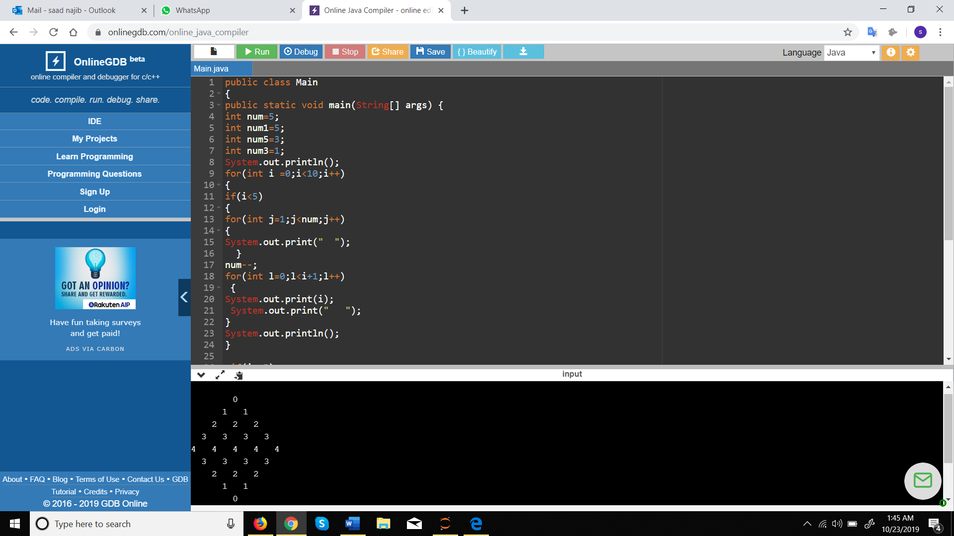

3. Create and test regex for the following. Also show the start and end index.

• valid integer number

String text = "16102019";

String pattern= "\\d+";

Pattern re = Pattern.compile(pattern);

Matcher m = re.matcher(text);

System.out.println(m.matches());

• floating point number

System.out.println("Floating Point Number");

String text4 = "9.0";

String patt4 = "\\d*.\\d*";

Pattern re4 = Pattern.compile(patt4);

Matcher m4 = re4.matcher(text4);

System.out.println(m4.matches());’

• valid C language identifier

String text = "_*\\w";